**Infographic**

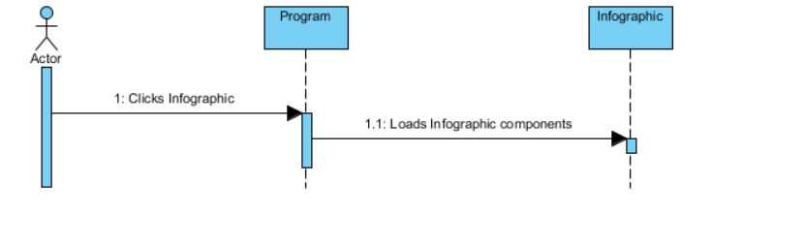

**Quiz**

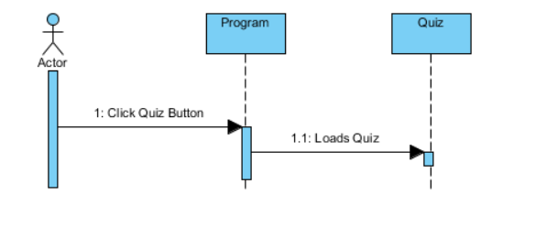

**Combustion System**

**Combustion System (Normal)**

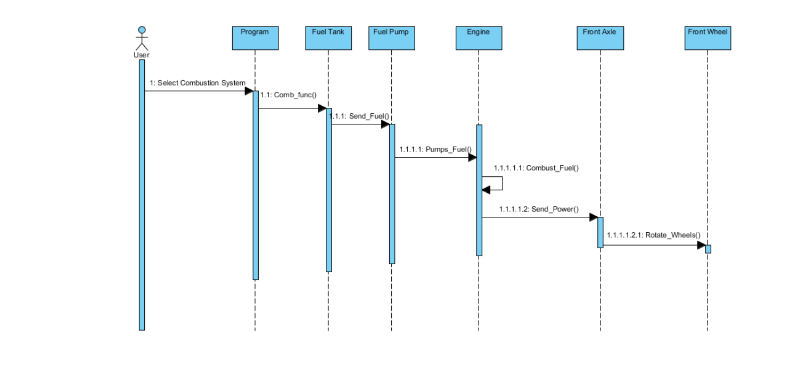

**Combustion System (Inclined)**

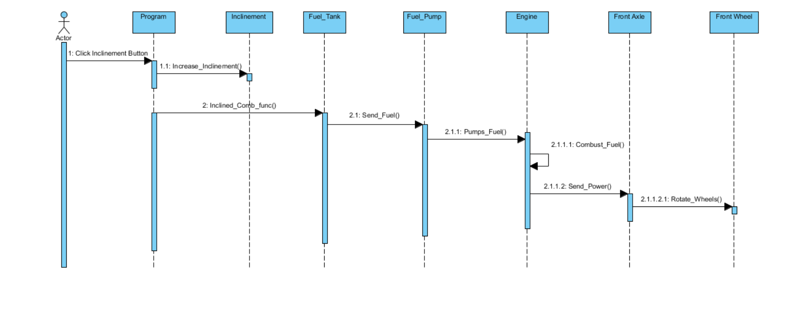

**Combustion System (Low Fuel)**

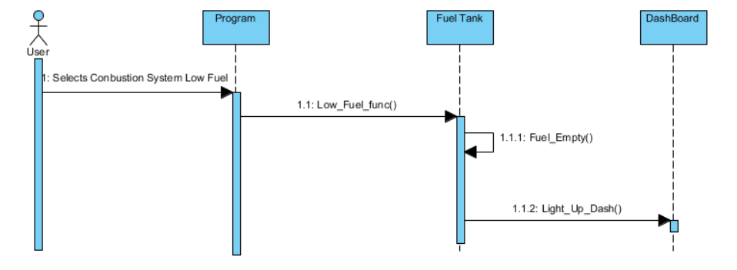

**Combustion System (Incorrect Fuel)**

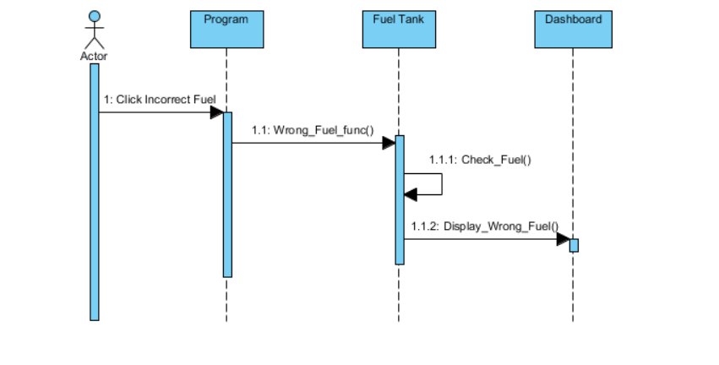

**Drive Wheel System**

**Front Wheel Drive**

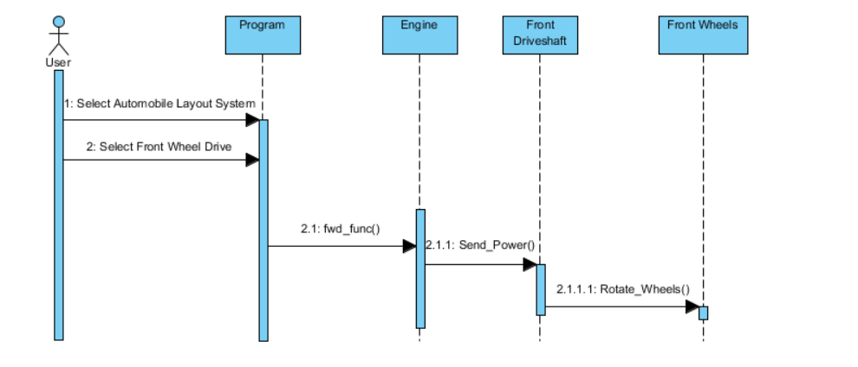

**Rear Wheel Drive**

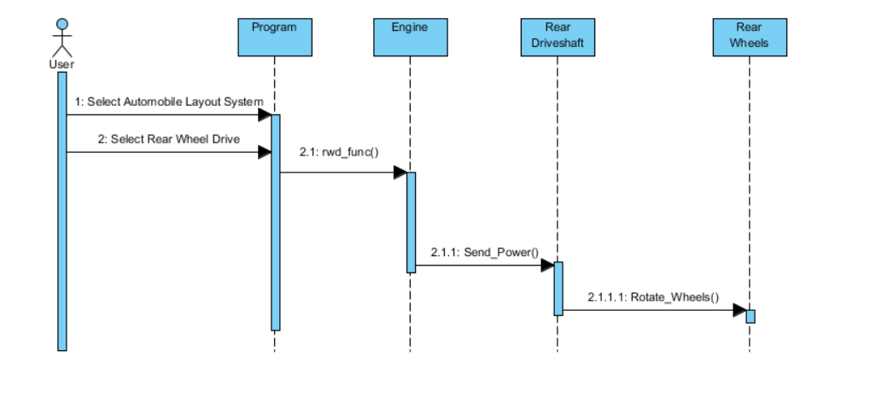

**Four Wheel Drive**

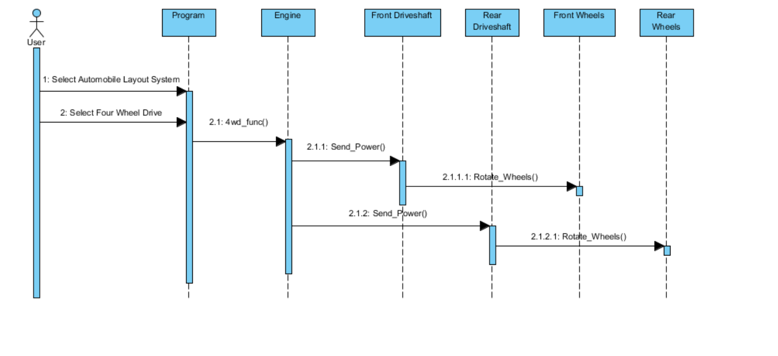

**Cooling System**

**Cooling System (Normal Temp)**

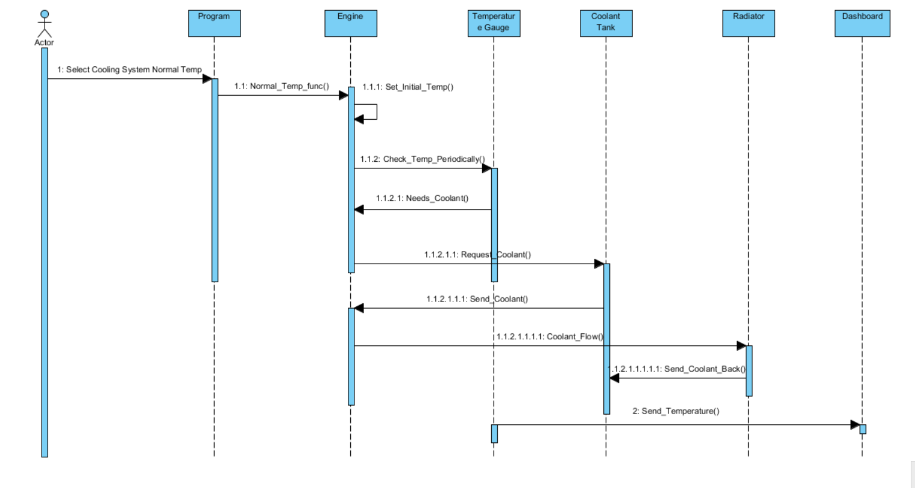

**Cooling System (High Temp)**

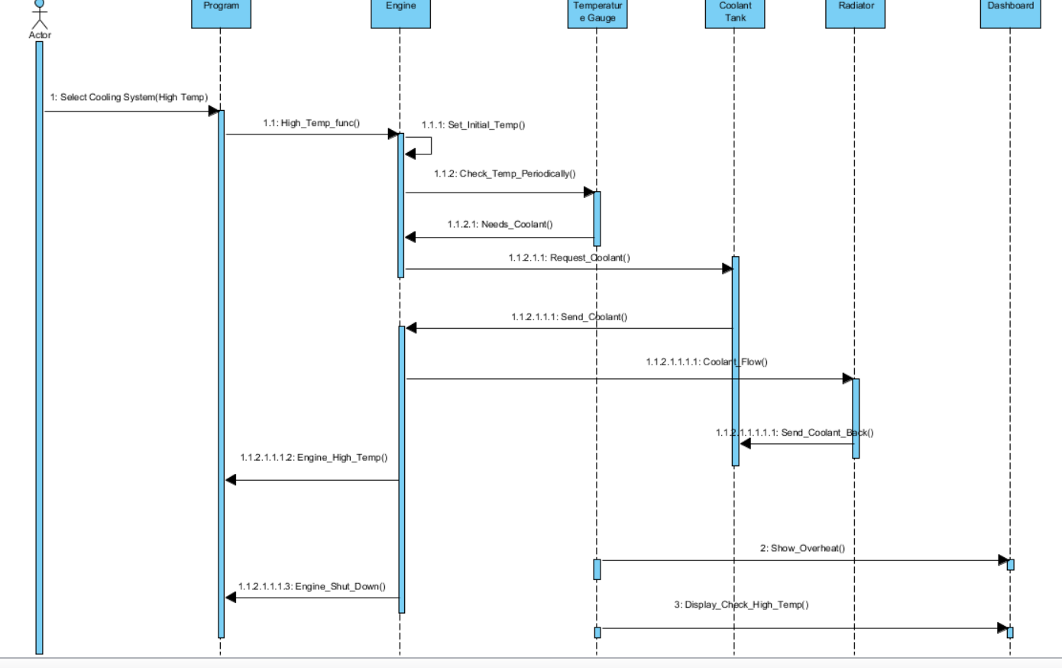

**Electrical System**

**Electrical System (Audio System)**

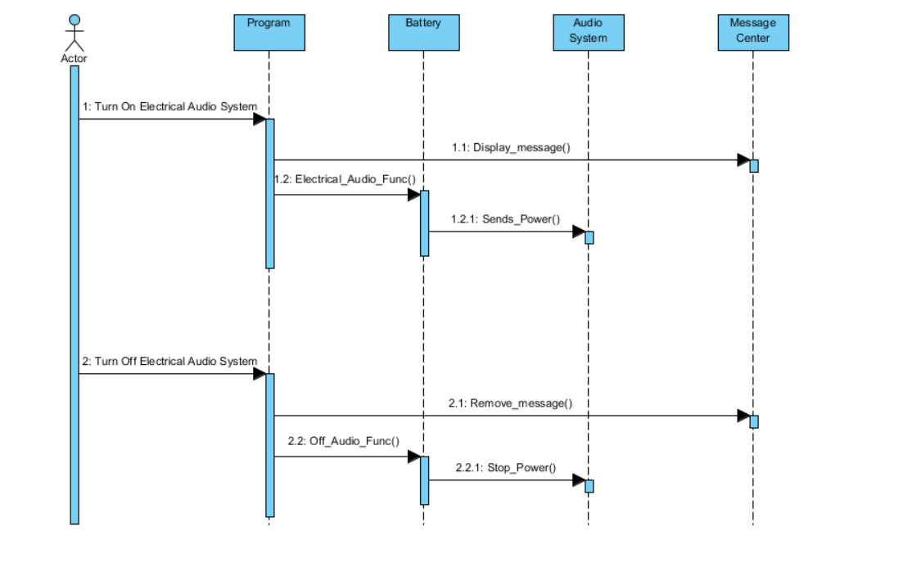

**Electrical System (Cruise Control)**

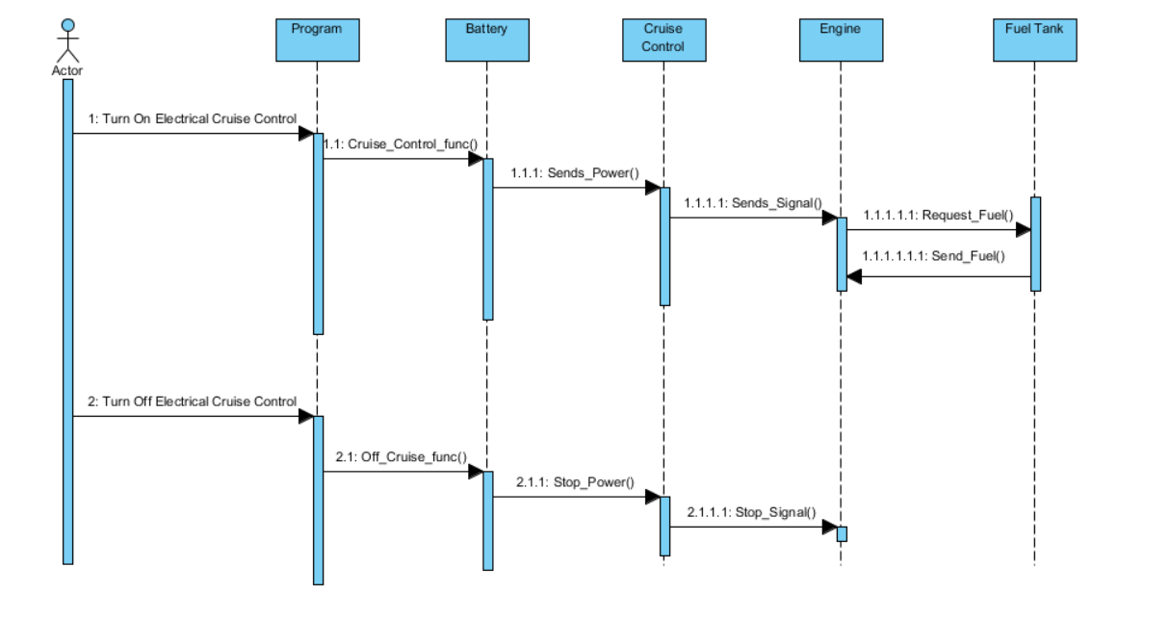

**Electrical System (Defrost Rear)**

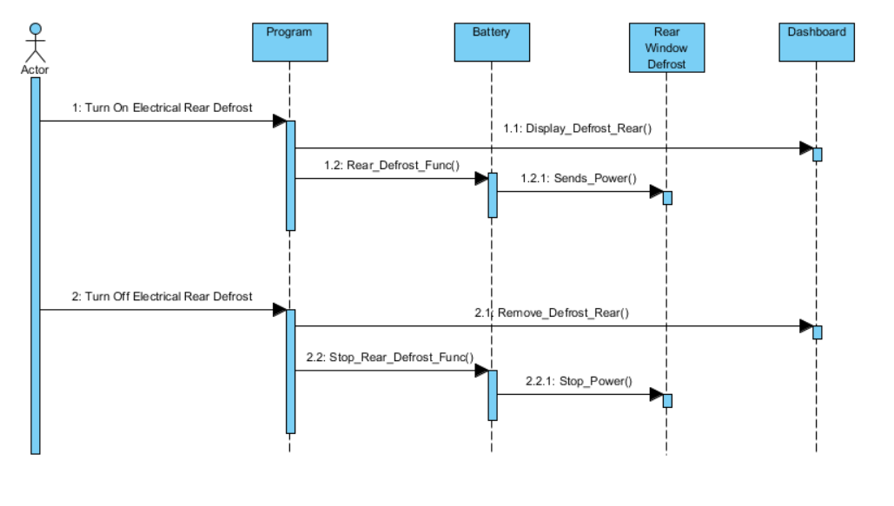

**Electrical System (Light Rear Fog Lights)**

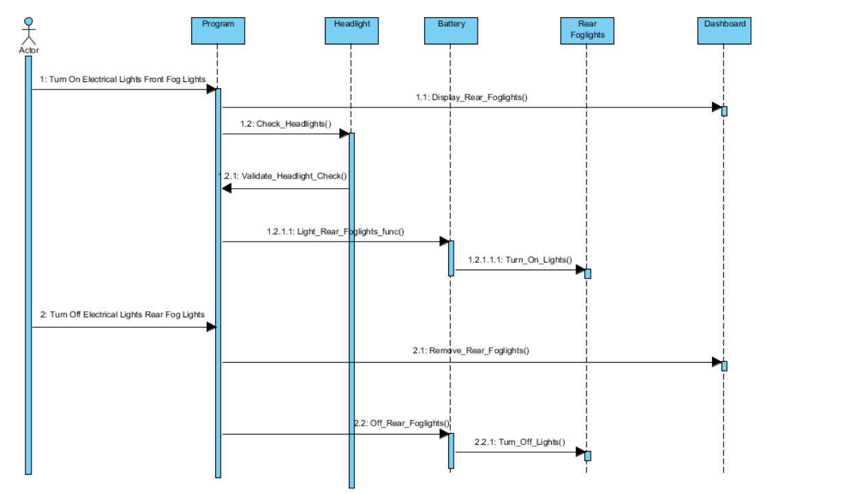

**Electrical System (Light Front Fog Lights)**

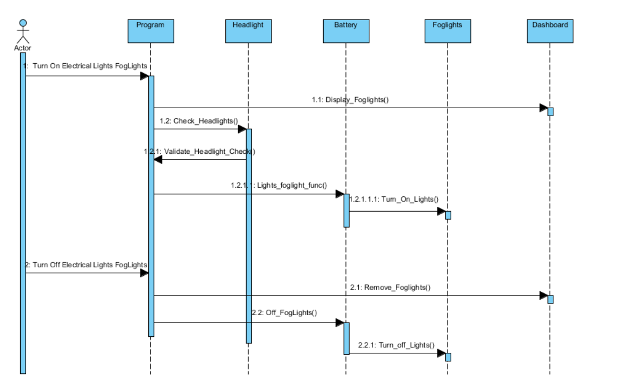

**Electrical System (Light Hazard Lights)**

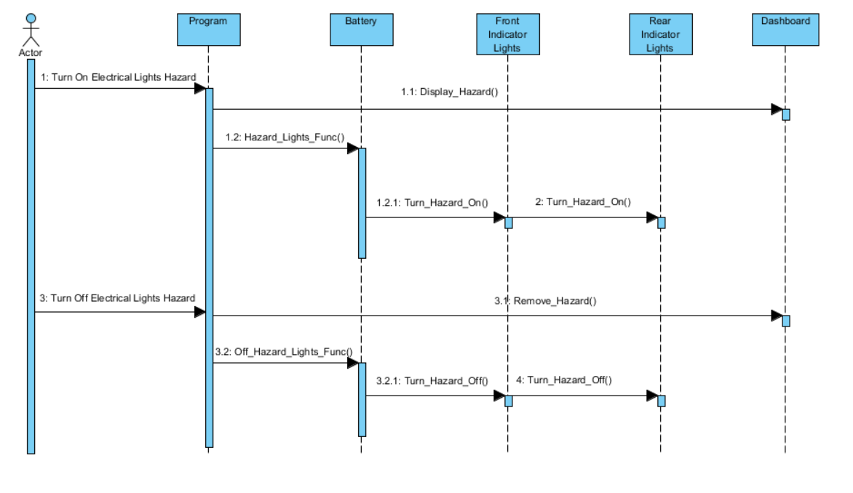

**Electrical System (Light Headlights)**

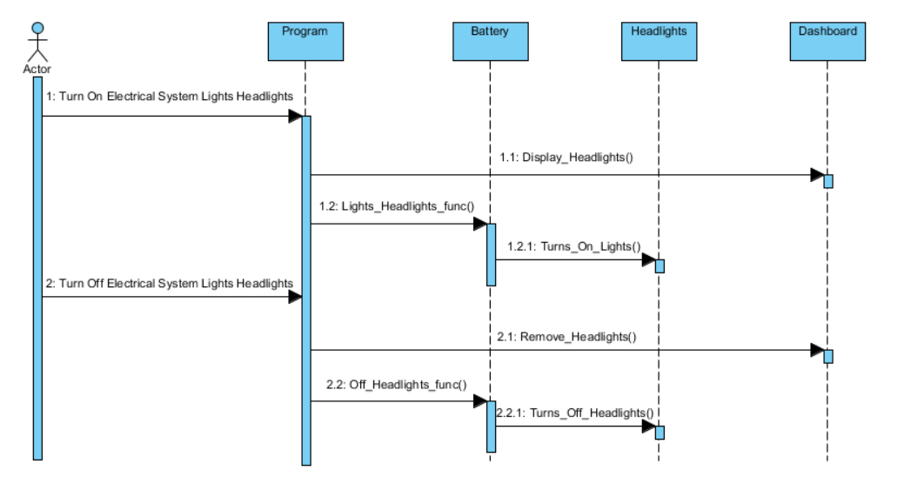

**Electrical System (Light High beams)**

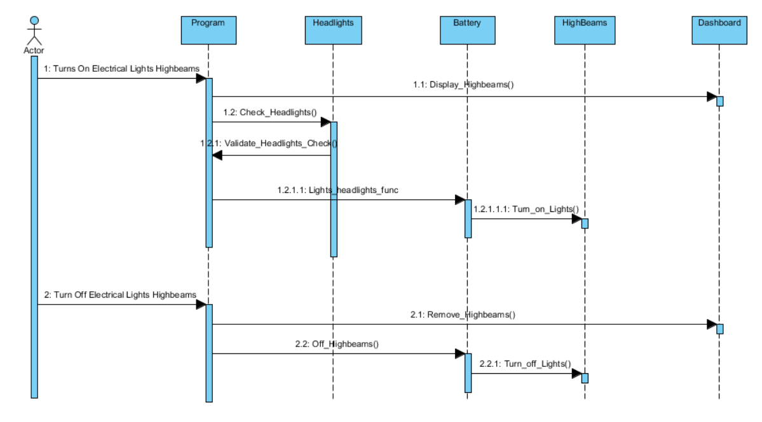

**Electrical System (Wiper)**

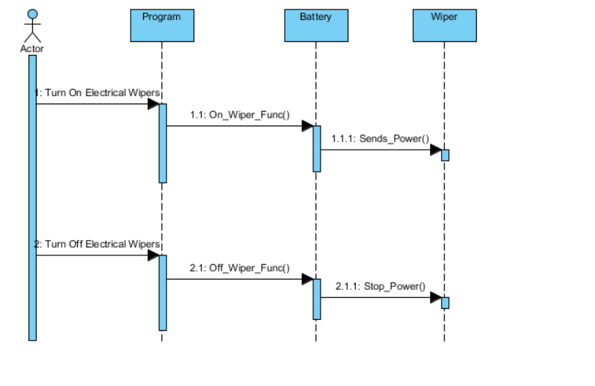

**Steering System**

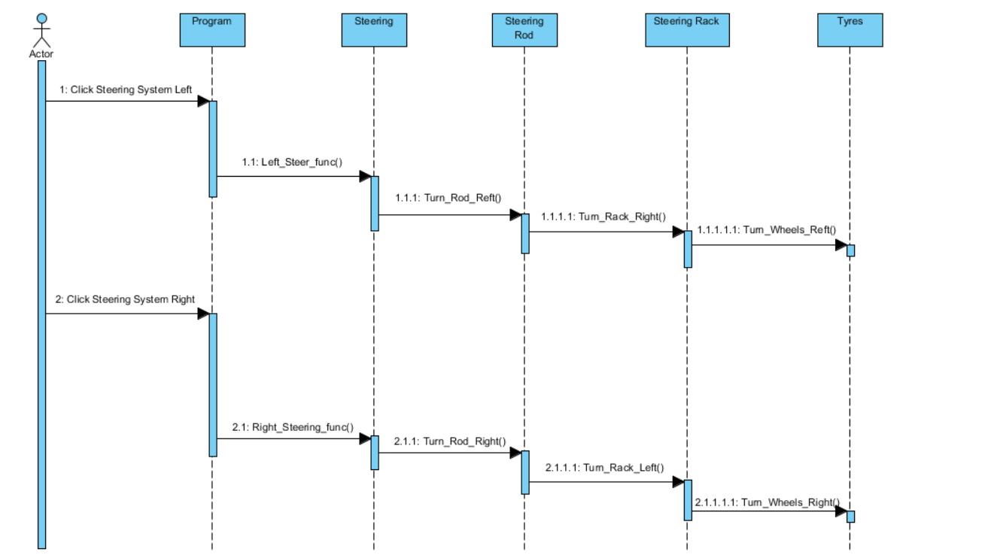

**Braking System**

**Braking System (Foot Brake)**

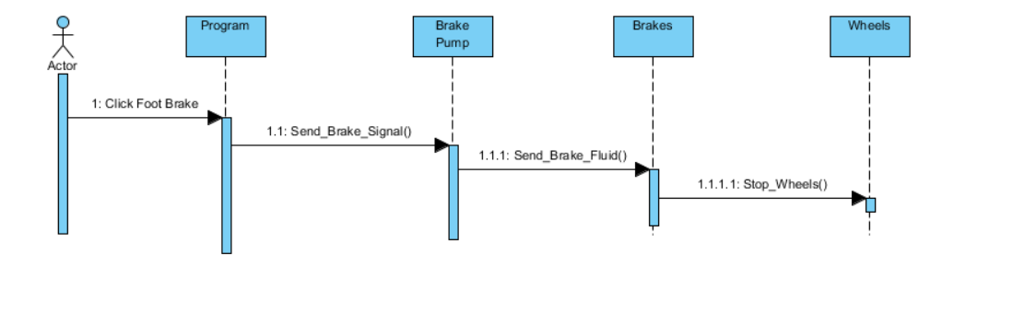

**Braking System (Hand Brake)**

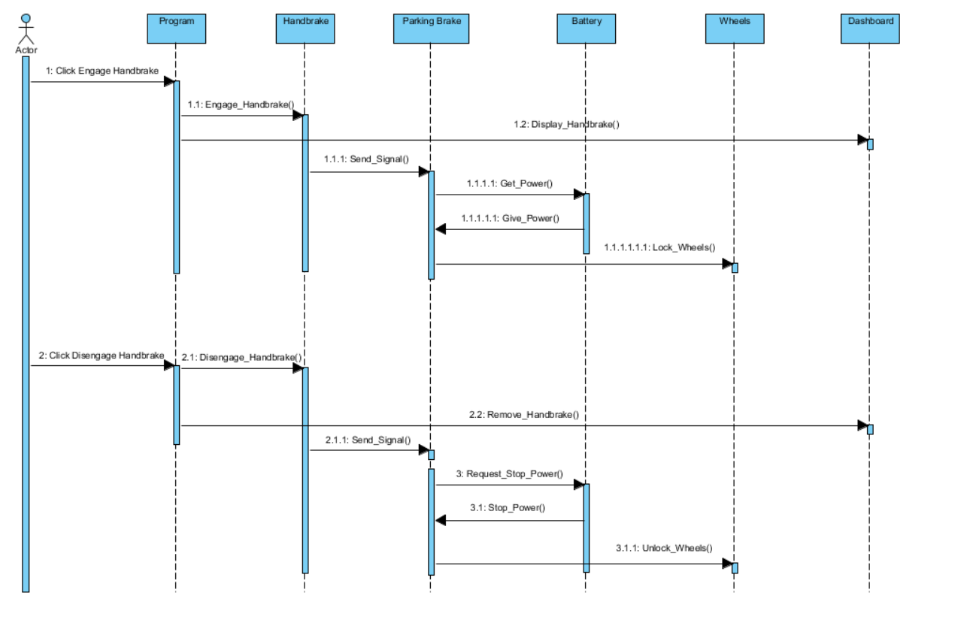

**Attachment System**

**Adding Attachment**

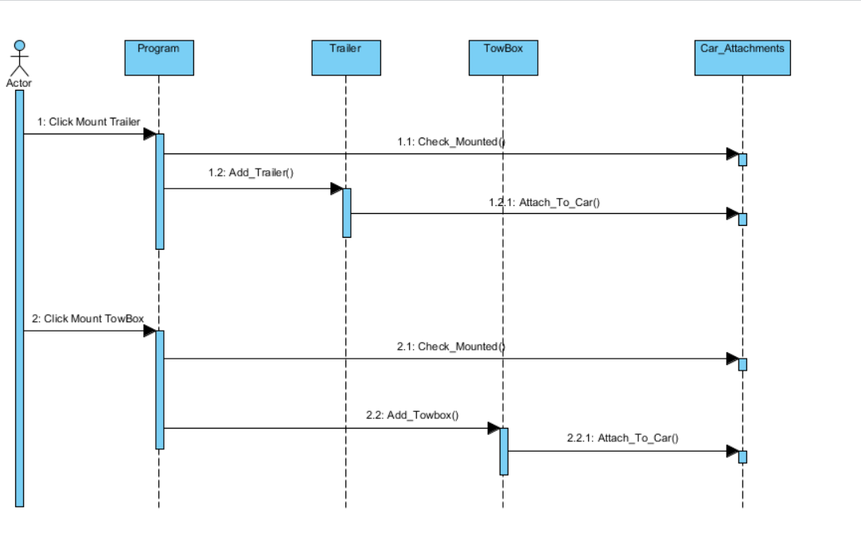

**Remove Attachment**

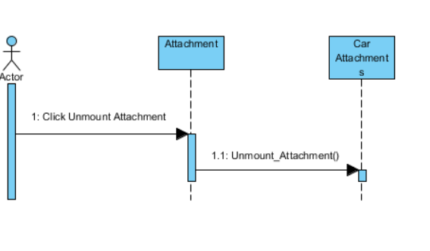

**Alternative Fuel System**

**Alternative Fuel System (Electric)**

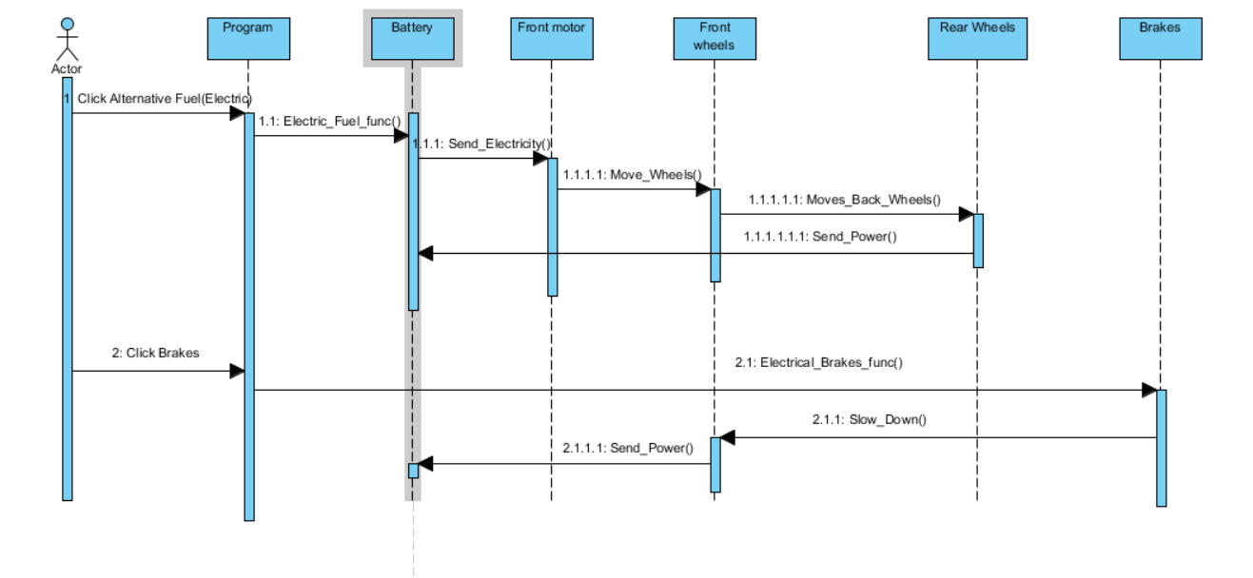

**Alternative Fuel System (Hydrogen)**

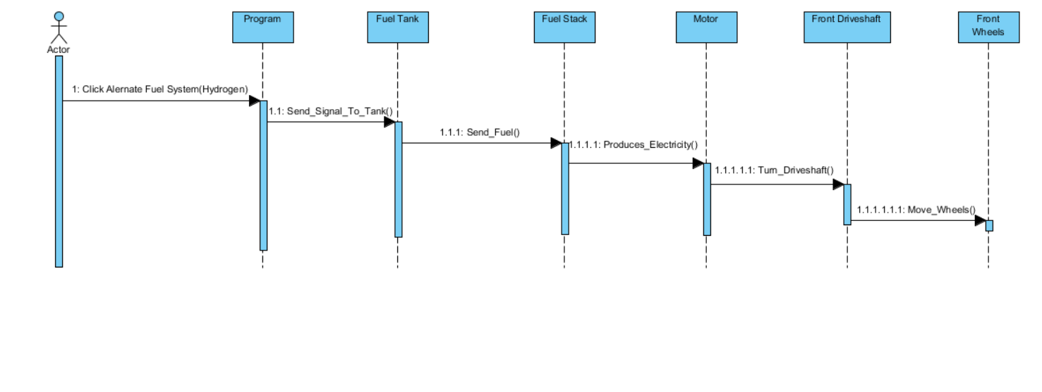

**Alternative Fuel System (Hybrid)**

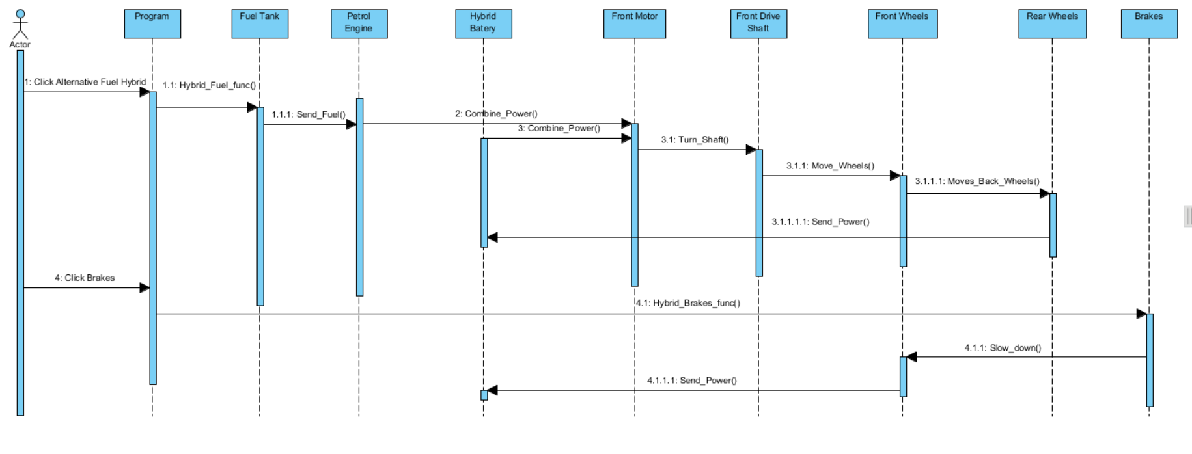

**High Altitude Driving System**

